**Report on Project Setup   
Project 1 Vue StoreFront**

**Steps:**

1. I started by installing the prerequisite components for the application, which was a challenging task. This involved setting up various dependencies such as Node, Yarn, NPM, Magento, and other required elements. After successfully installing these dependencies, I initiated the project setup by running the command **"npx @vue-storefront/cli generate store"** and proceeded to follow the documentation for the installation process.

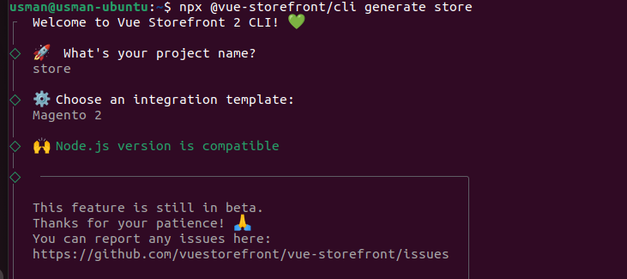

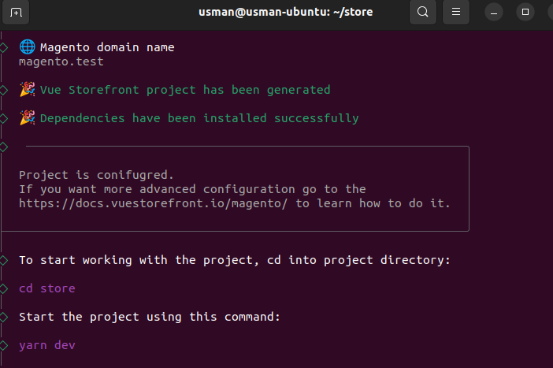

1. After that, I went to the project folder with the "cd" command and used "yarn" to install the required modules. This ran the application on my local host.



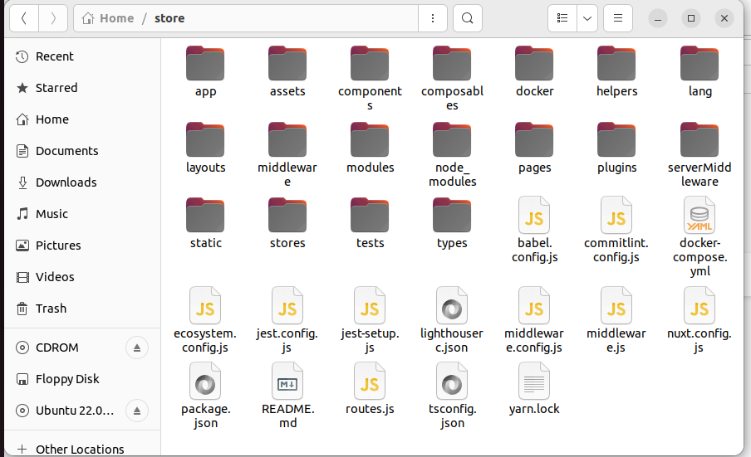

1. Then I opened the browser and write the localhost 3000 and run it then application run successfully on local host.

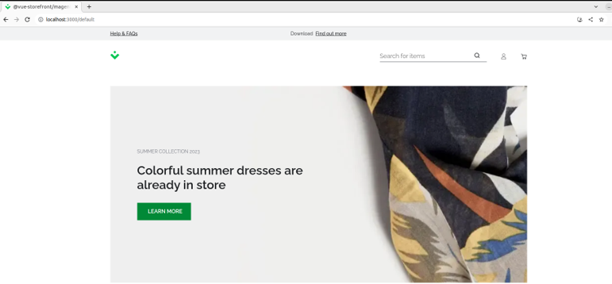

Problems:

1. Installing dependencies
2. Errors in Npm verison